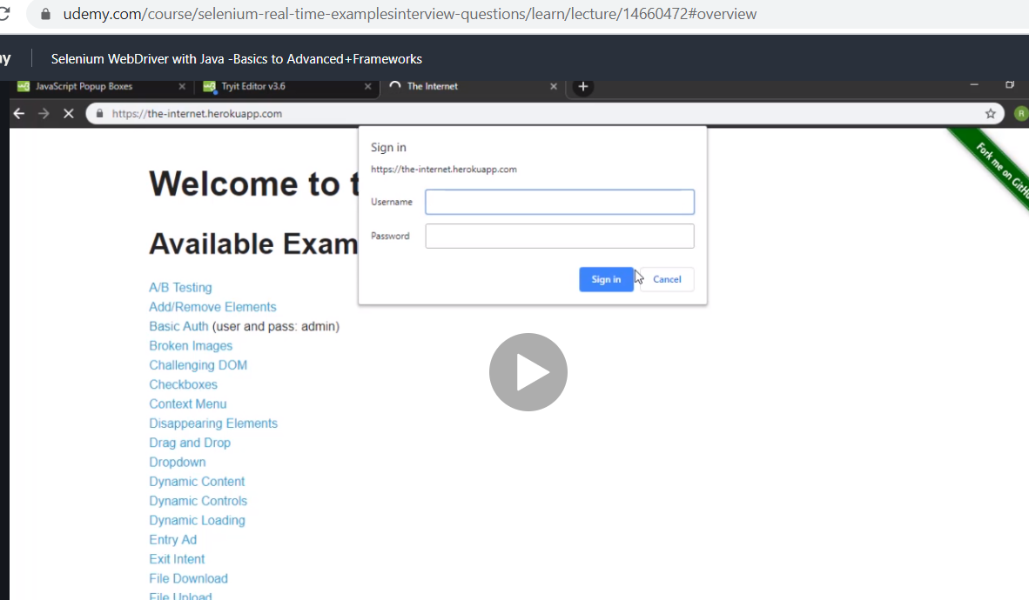

This is not java alert this is windows handling

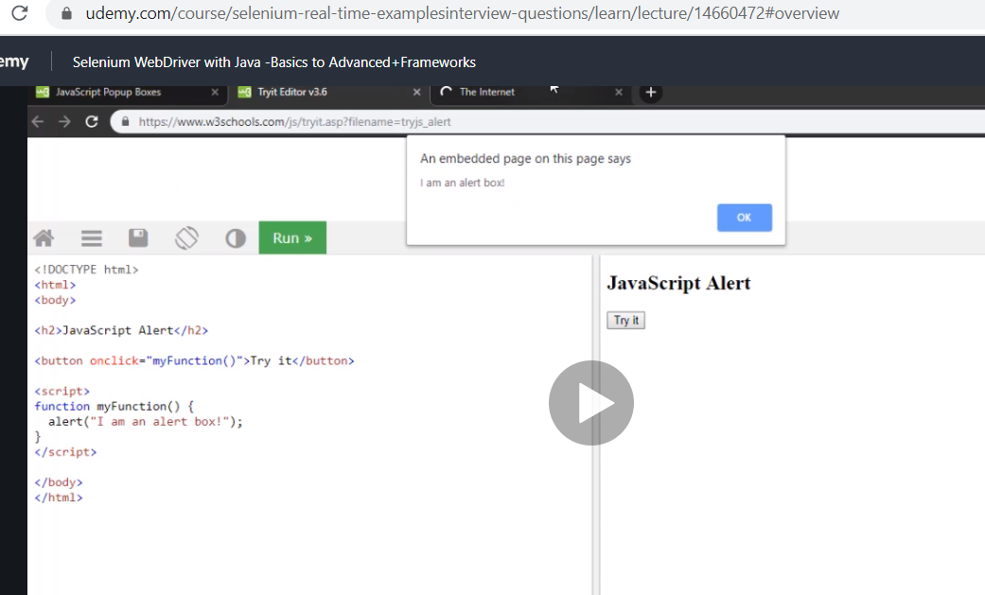

This is for java alert switch

Google internet herokuapp

<https://the-internet.herokuapp.com/>

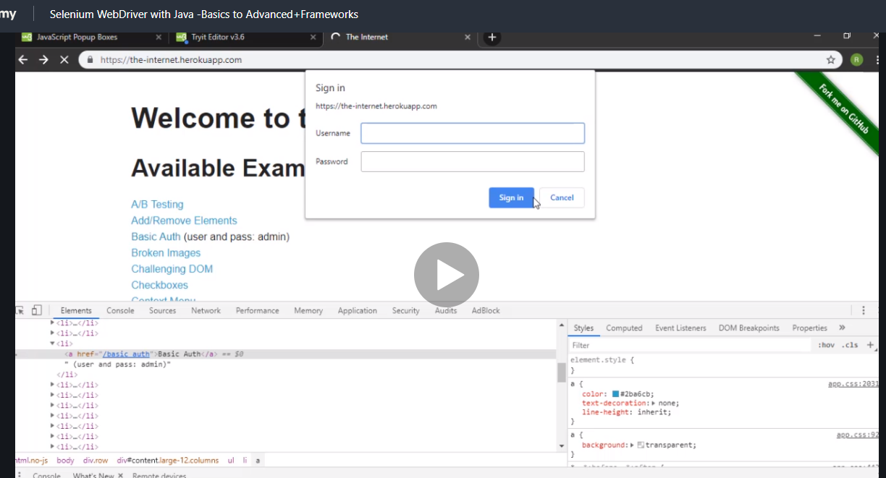

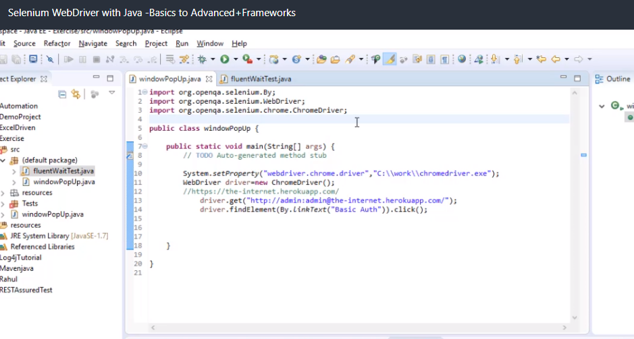

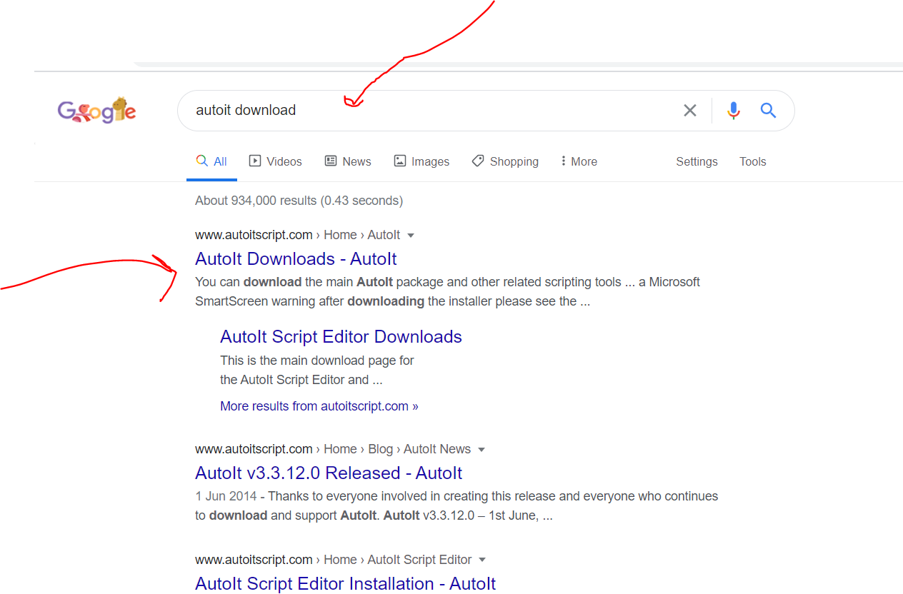

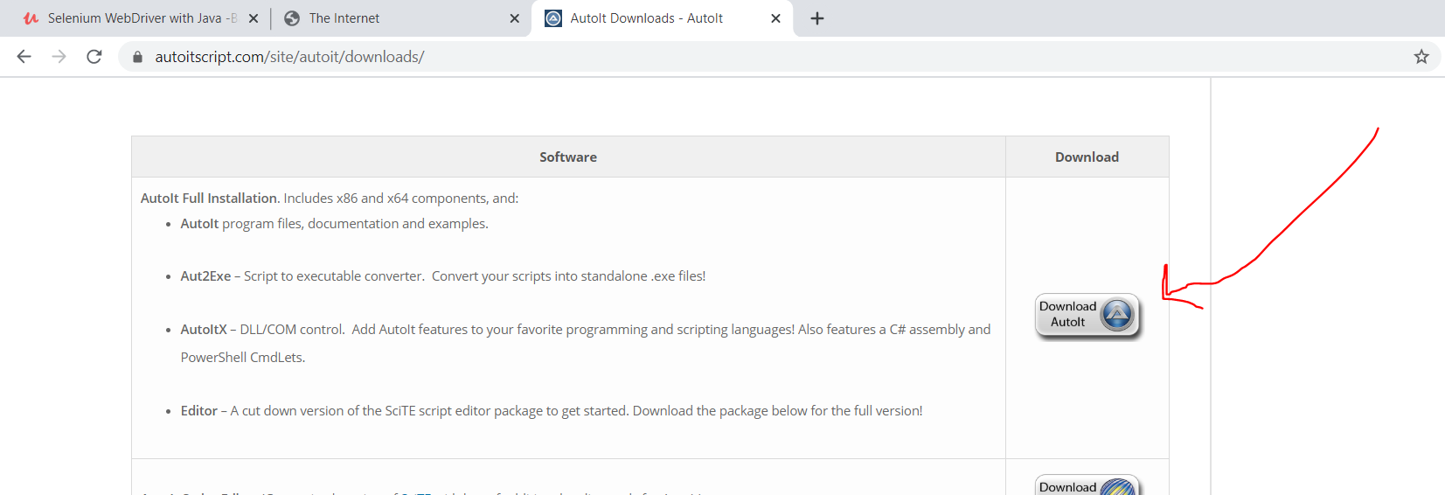

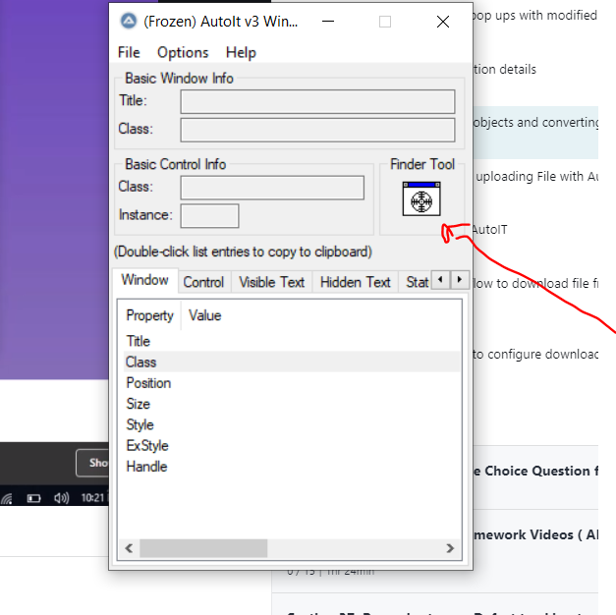

Click and drag that scary voodoo looking circle and drop on where u want

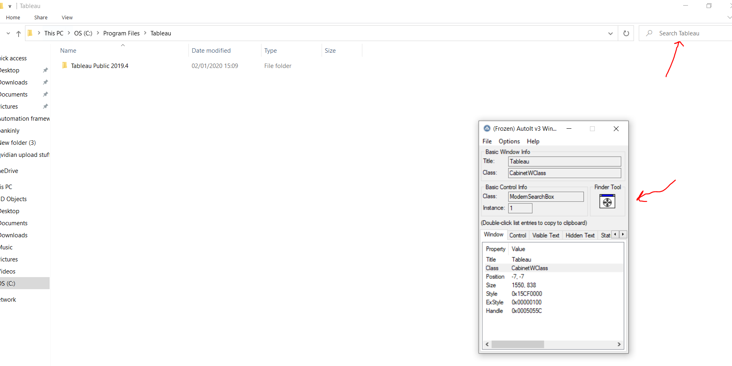

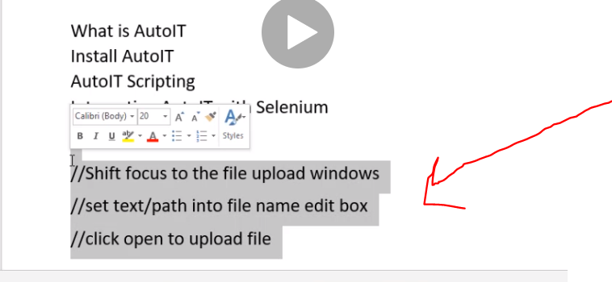

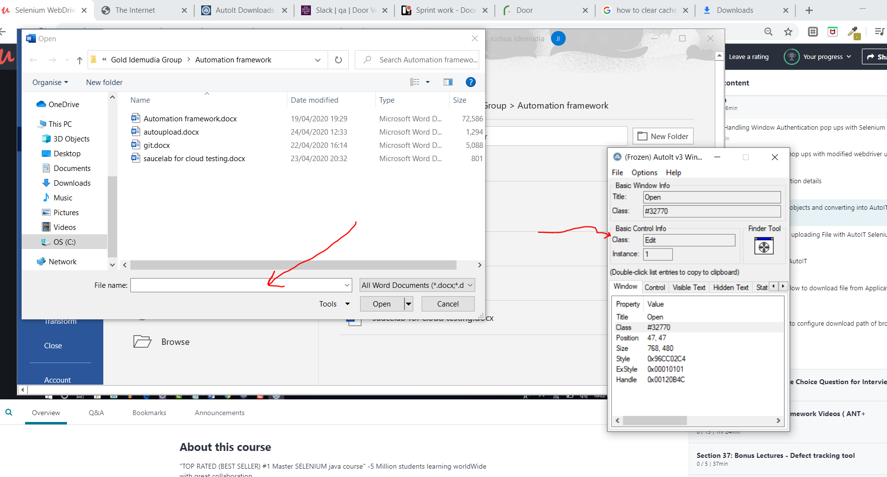

Class is an edit box so we write script

Next we go back to autoit editor

C:\Program Files (x86)\AutoIt3\SciTE

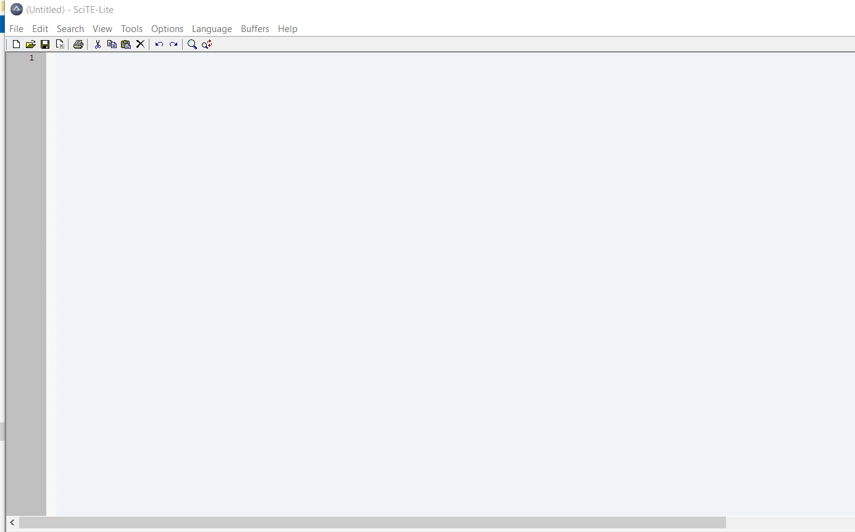

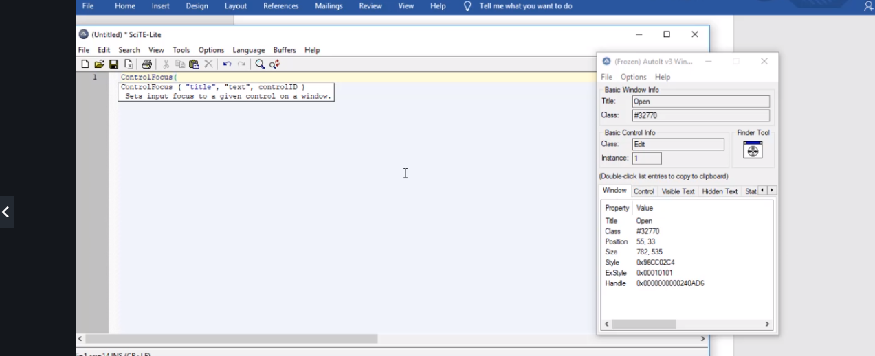

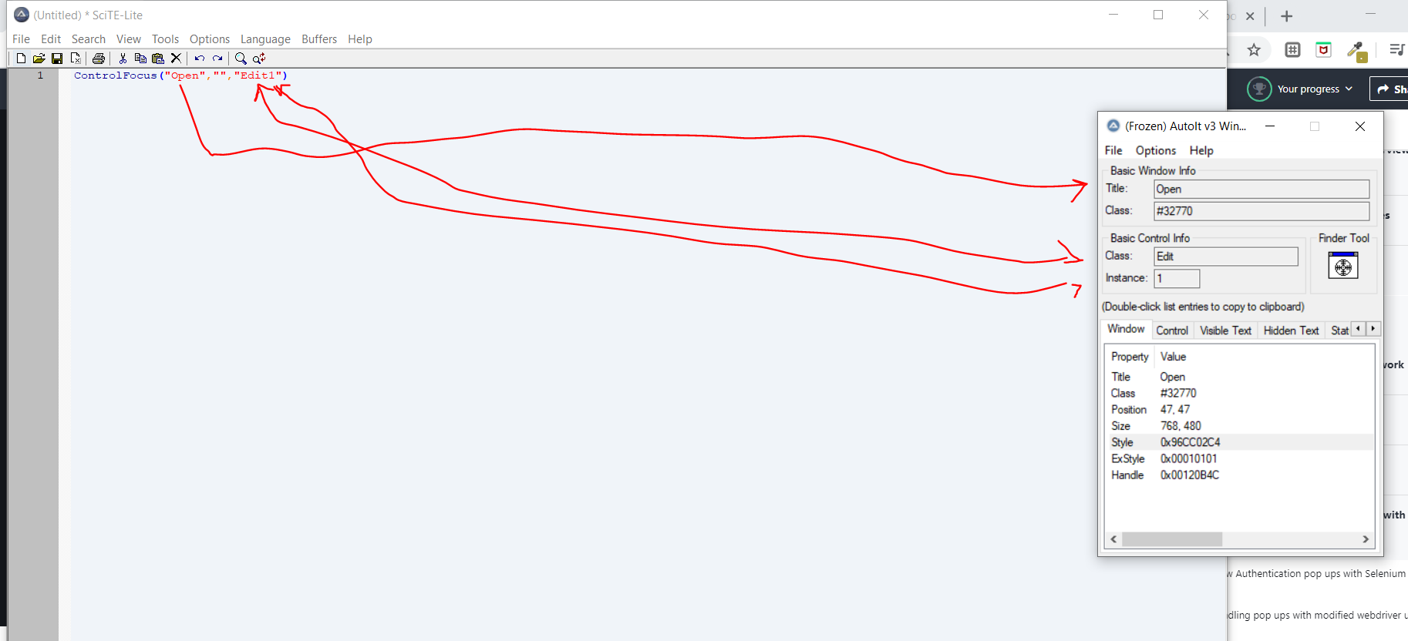

This is to shift focus to your file

Get the link C:\Users\JoshuaIdemudia\Desktop\Gold Idemudia Group\Python\Python.docx

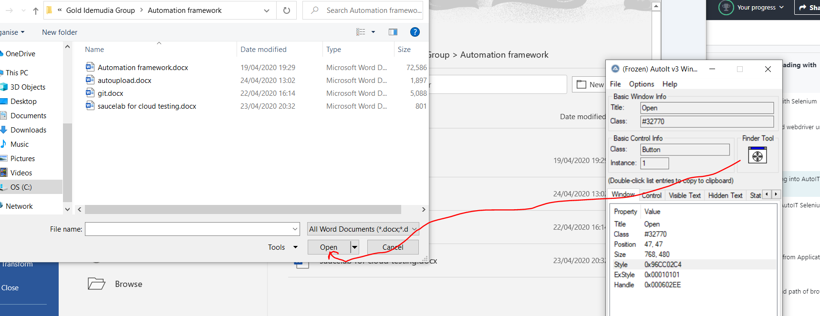

Next drag and get the button

Then we add click to the script

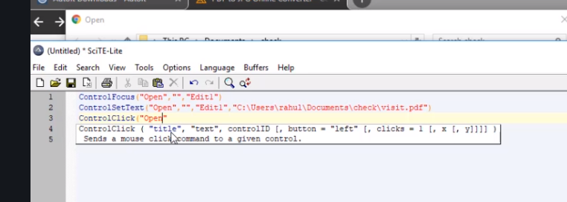

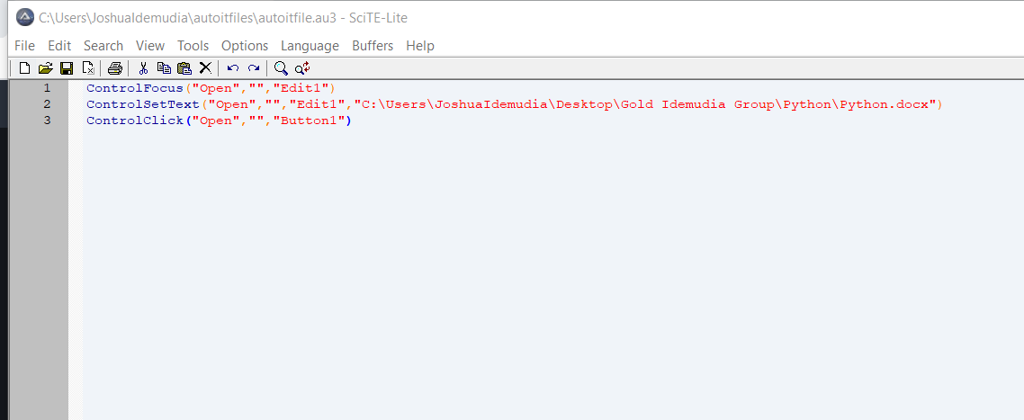

Next save it

C:\Users\JoshuaIdemudia\autoitfiles

Go into it and observe its now a au3 file, then right click and complie(x86)

You get an exe file afterwards

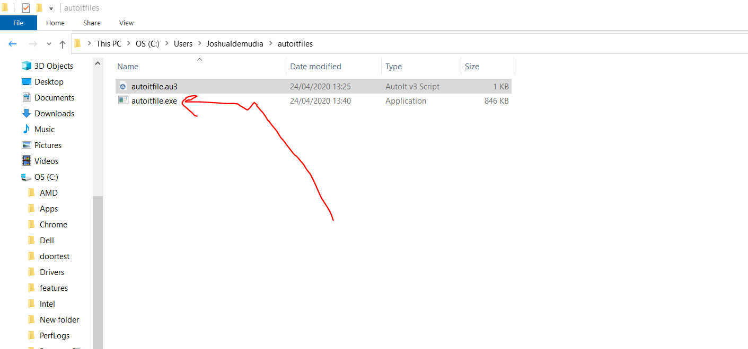

Now lets start this is also cool cos we can just use a script to convert it

<https://altoconvertpdftoword.com/>

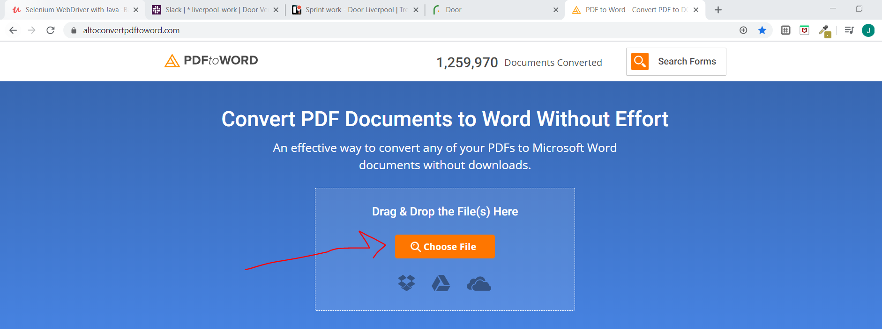

Spy the element

**import** java.io.IOException;

**import** org.openqa.selenium.By;

**import** org.openqa.selenium.WebDriver;

**import** org.openqa.selenium.chrome.ChromeDriver;

**public** **class** fileupload {

**public** **static** **void** main(String[] args) **throws** InterruptedException, IOException {

// **TODO** Auto-generated method stub

System.*setProperty*("webdriver.chrome.driver", "C:\\Chrome\\chromedriver.exe");

WebDriver driver = **new** ChromeDriver();

driver.get("https://altoconvertpdftoword.com/");

driver.findElement(By.*xpath*("//*[@id='dropzoneInput-label']")).click();

Thread.*sleep*(3000);

Runtime.*getRuntime*().exec("C:\\Users\\JoshuaIdemudia\\autoitfiles\\autoitfile.exe");

}

}

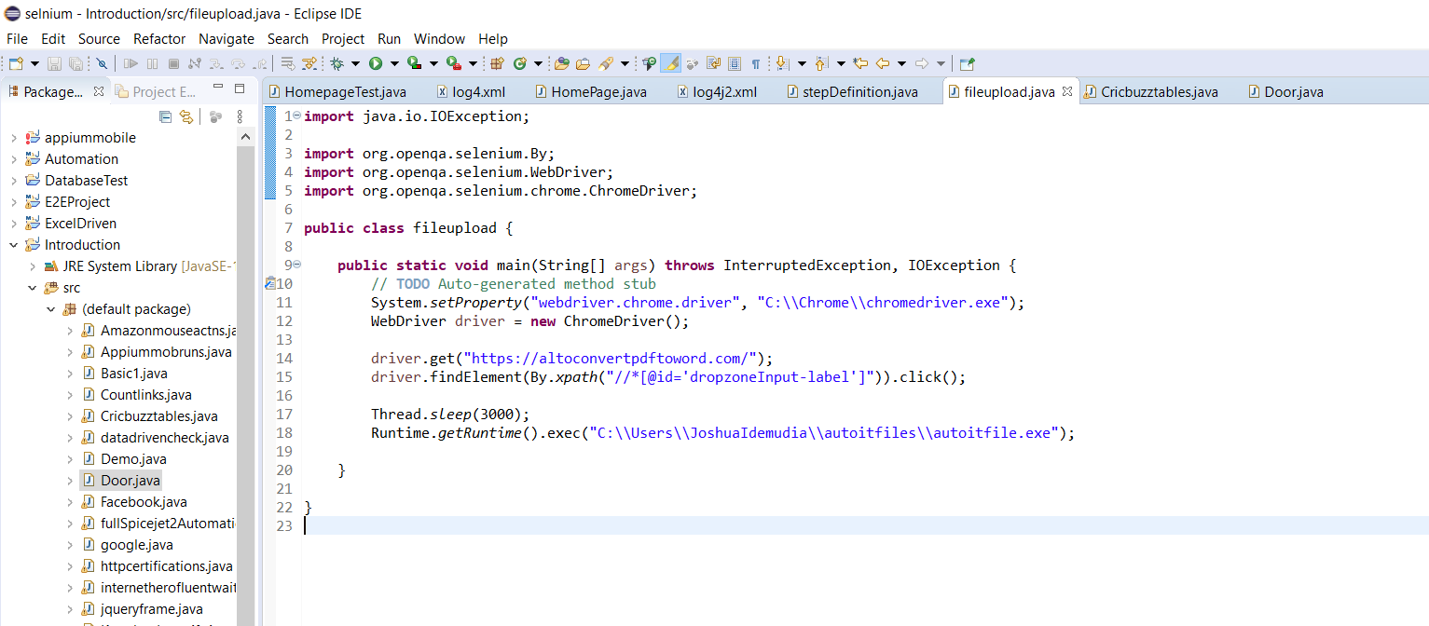

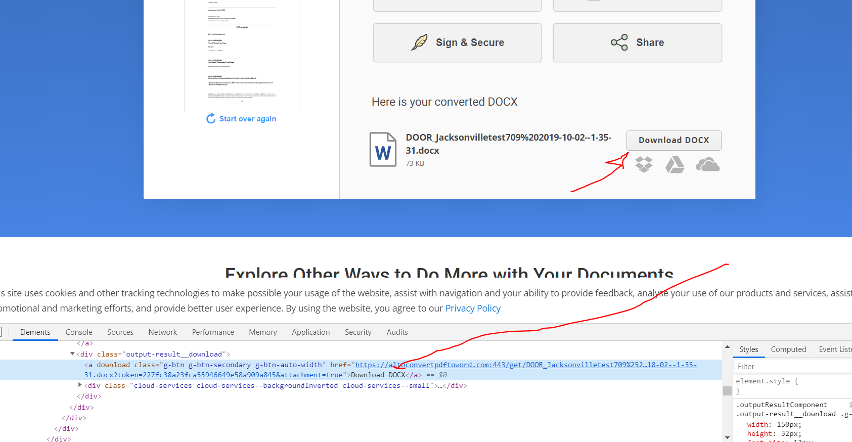

Download by linktest by the way we use waits to make it wait

Now the next thing is to verify that the file has been downloaded this is done by knowing where it was downloaded . all downloads are in download folder so find it there.

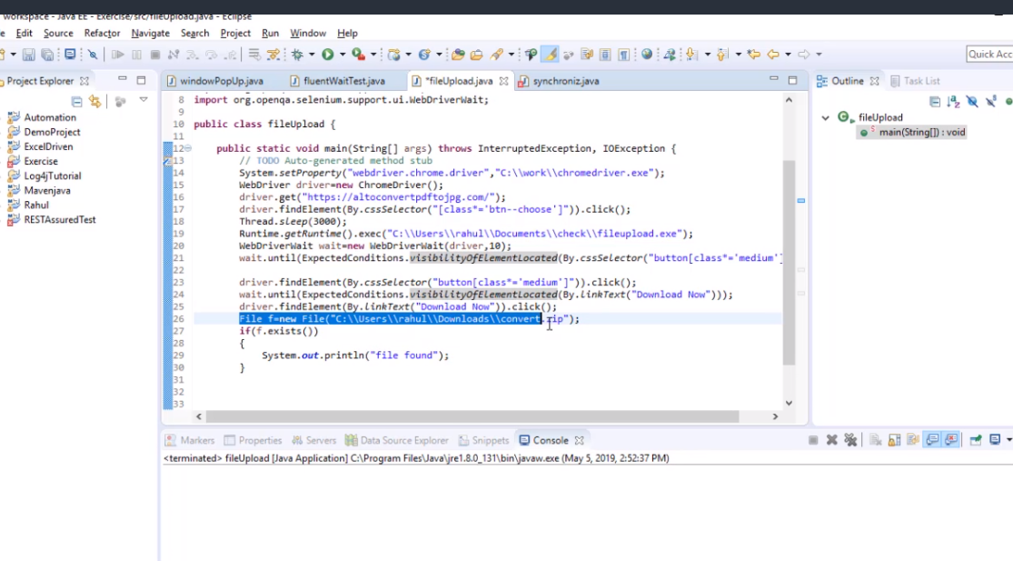

Now the way above only works on your computer but with this below will work on anyones system.

Now set experiment java code below downloads whatever you want to the project and you can dynamically drive it without hard coding.

We use put to save two stuffs in the code

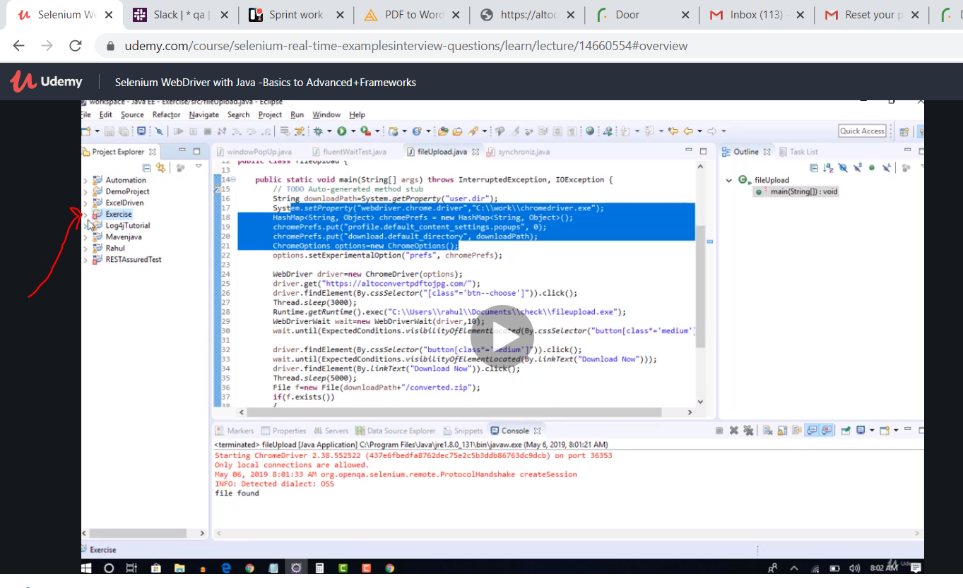

It now downloads in exercise folder rather than in downloads folder.

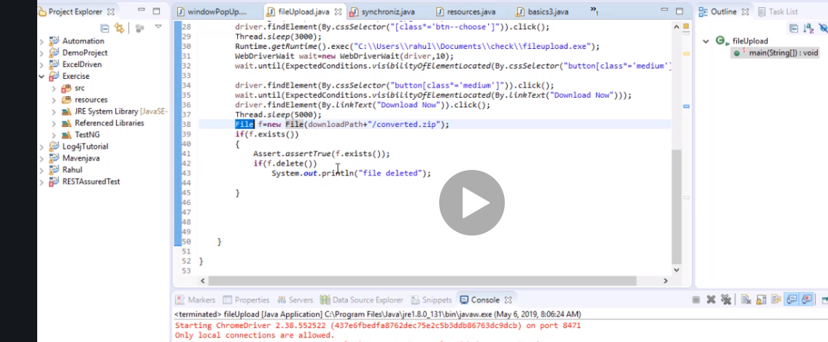

So finds it yes deletes it yes

This is the code to do it to run on any machine

import java.io.File;

import java.io.IOException;

import java.util.HashMap;

import org.testng.Assert;

import org.testng.annotations.Test;

import org.openqa.selenium.By;

import org.openqa.selenium.WebDriver;

import org.openqa.selenium.chrome.ChromeDriver;

import org.openqa.selenium.chrome.ChromeOptions;

import org.openqa.selenium.support.ui.ExpectedConditions;

import org.openqa.selenium.support.ui.WebDriverWait;

public class fileUpload {

public static void main(String[] args) throws InterruptedException, IOException {

// TODO Auto-generated method stub

String downloadPath=System.getProperty("user.dir");

System.setProperty("webdriver.chrome.driver","C:\\work\\chromedriver.exe");

HashMap<String, Object> chromePrefs = new HashMap<String, Object>();

chromePrefs.put("profile.default_content_settings.popups", 0);

chromePrefs.put("download.default_directory", downloadPath);

ChromeOptions options=new ChromeOptions();

options.setExperimentalOption("prefs", chromePrefs);

WebDriver driver=new ChromeDriver(options);

driver.get("https://altoconvertpdftojpg.com/");

driver.findElement(By.cssSelector("[class*='btn--choose']")).click();

Thread.sleep(3000);

Runtime.getRuntime().exec("C:\\Users\\rahul\\Documents\\check\\fileupload.exe");

WebDriverWait wait=new WebDriverWait(driver,10);

wait.until(ExpectedConditions.visibilityOfElementLocated(By.cssSelector("button[class*='medium']")));

driver.findElement(By.cssSelector("button[class*='medium']")).click();

wait.until(ExpectedConditions.visibilityOfElementLocated(By.linkText("Download Now")));

driver.findElement(By.linkText("Download Now")).click();

Thread.sleep(5000);

File f=new File(downloadPath+"/converted.zip");

if(f.exists())

{

Assert.assertTrue(f.exists());

if(f.delete())

System.out.println("file deleted");

}

}

}